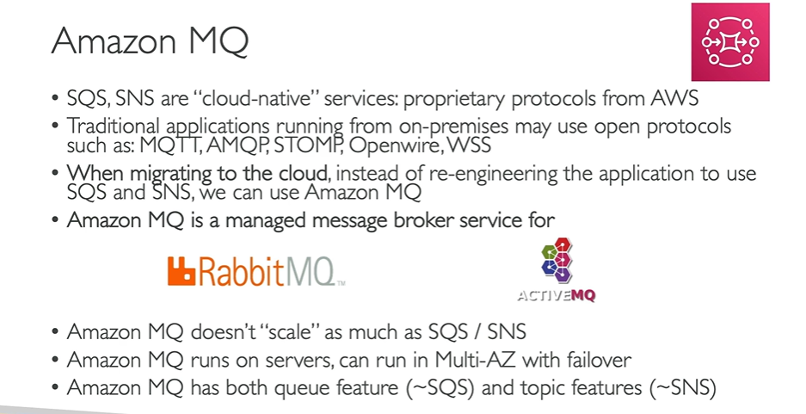

Amazon MQ is used if and only if the company is migrating from on-prem to cloud